COMP 3104 Assignment 1
Screenshot PDF
Name: Srushti Maheshkumar Patel
Student ID: 101485546

Local Repository Setup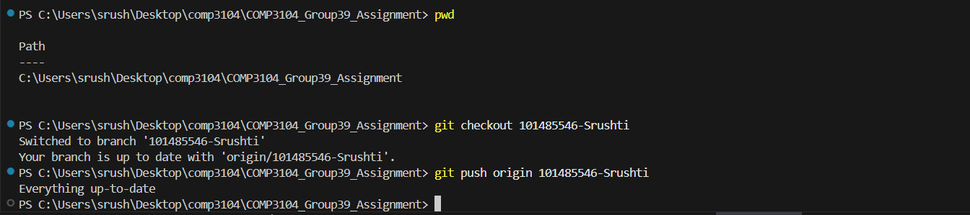

Git Commit History
First, second and third commit:
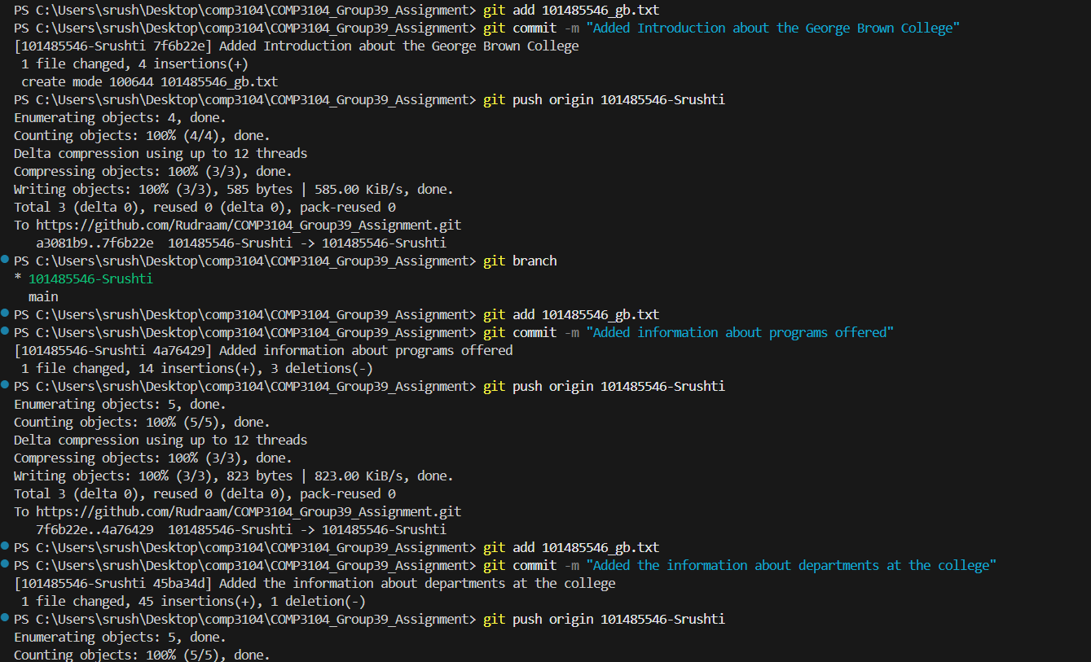
Fourth and Fifth commit:
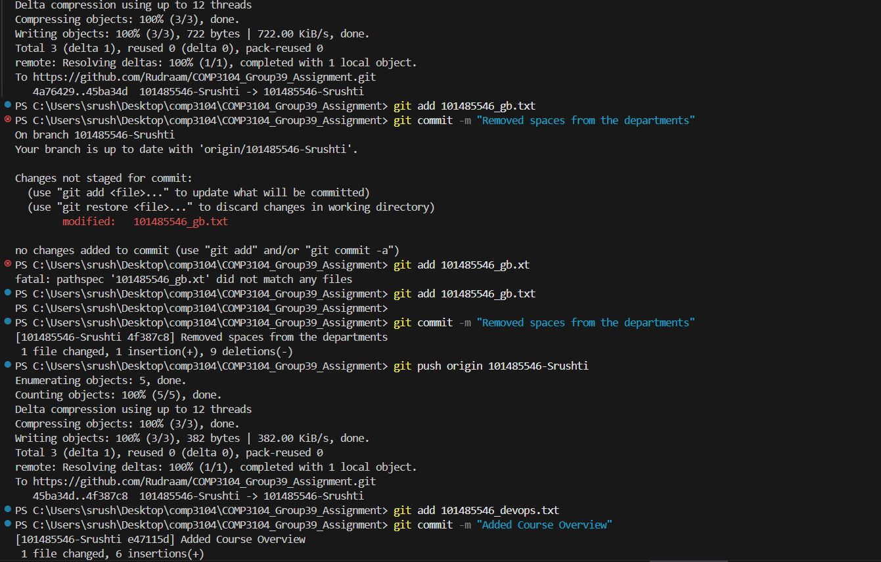

Sixth and Seventh commit:
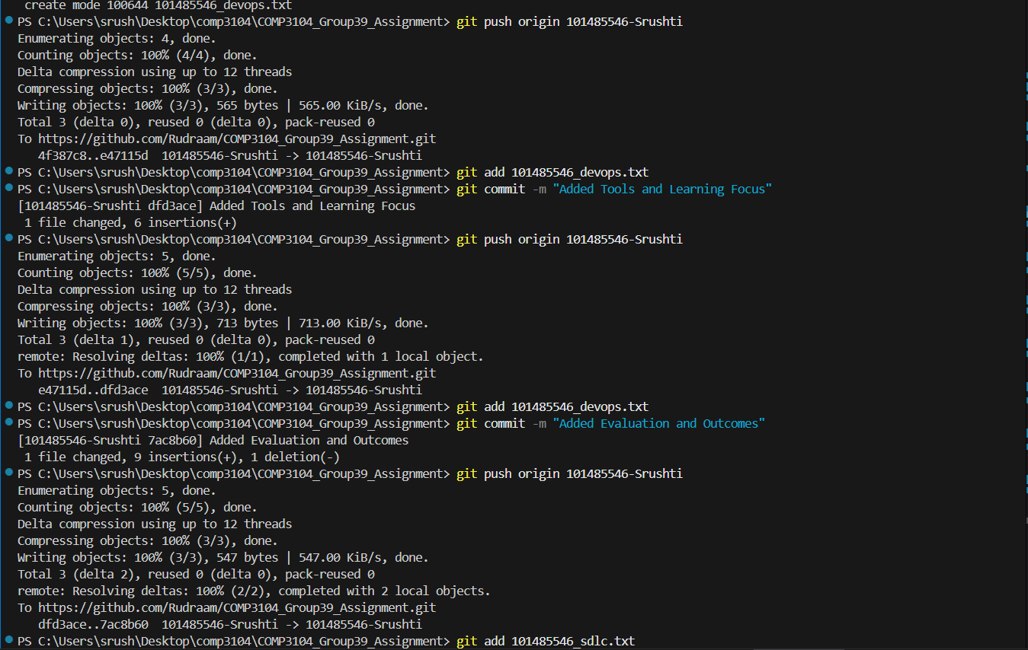
Eighth and Ninth Commit:
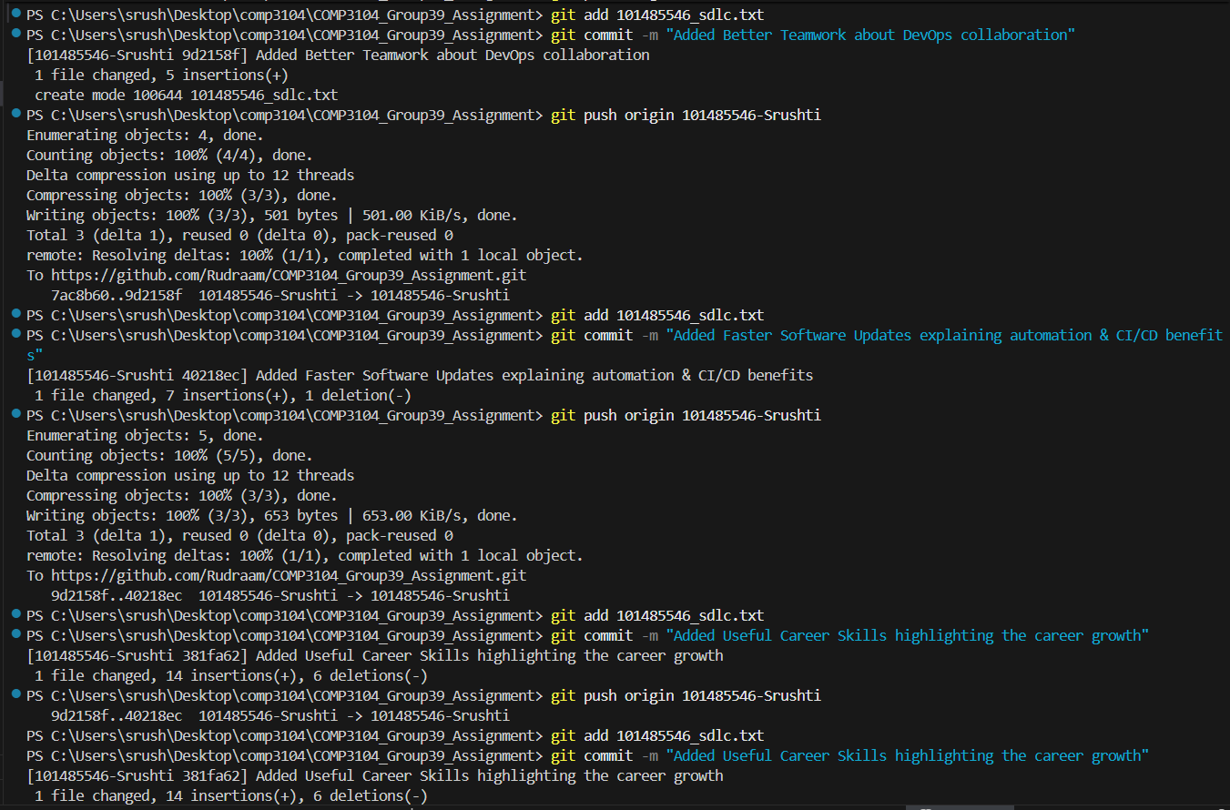

Tenth Commit: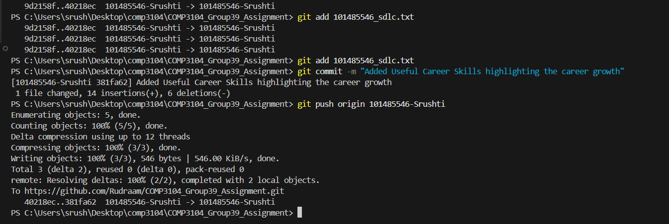

README.md Commit:
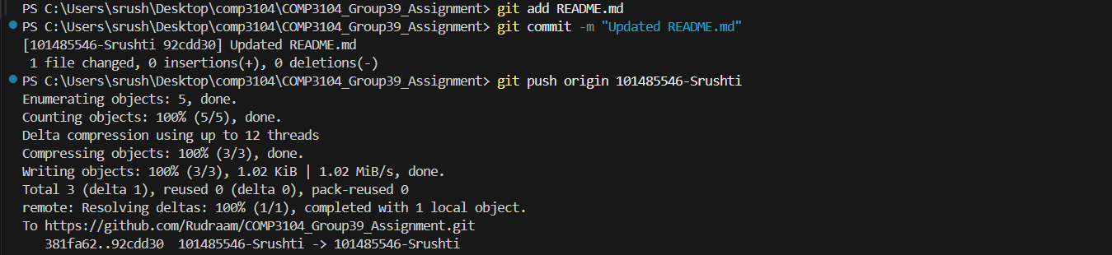
Commit History on GitHub: 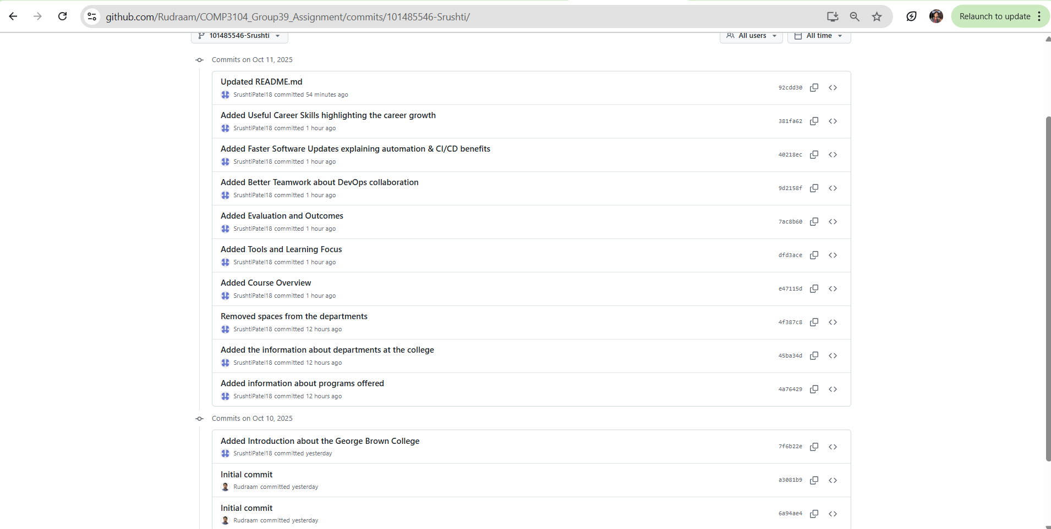

Branch Structure: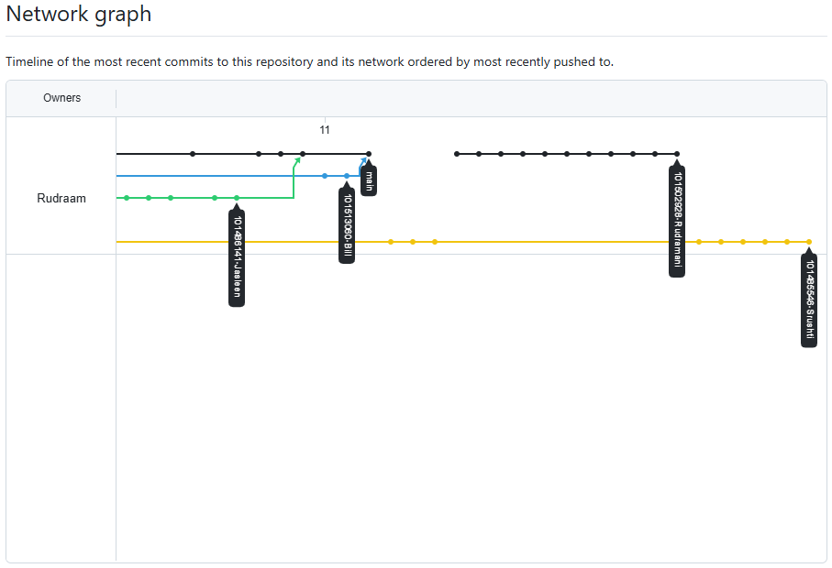
CI Pipeline Status: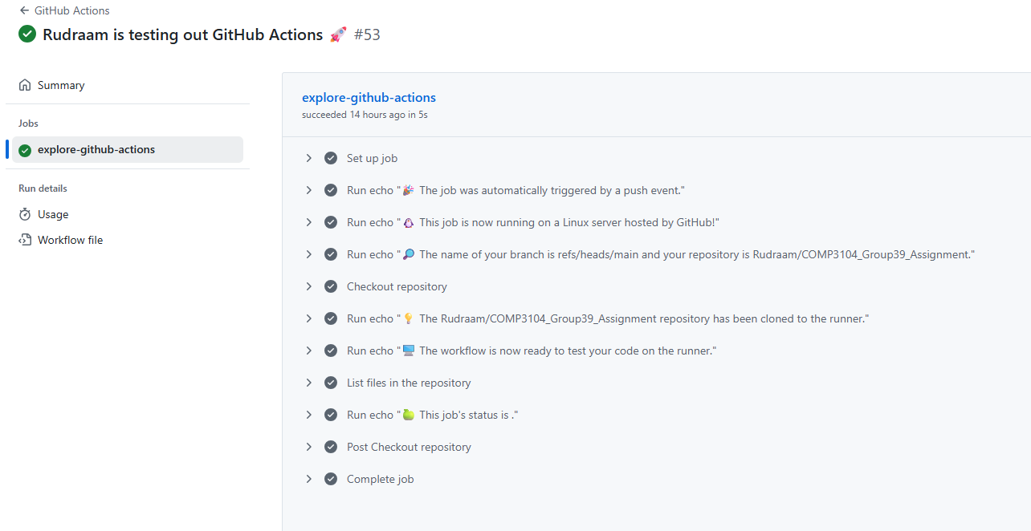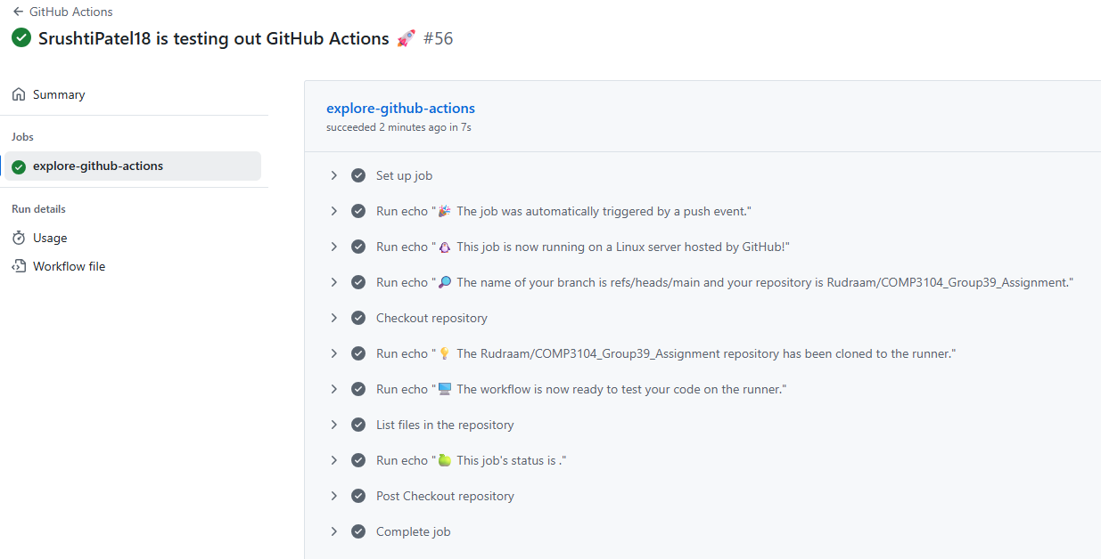

Merging the Branches: